WEEK 1 TO WEEK 6 ASSIGNMENT VERSION 2
Contents
WEEK 4: DATA MANAGEMENT 2
PRACTICAL EXERCISE DONE 2
TOOLS/SOFTWARES USED 6
PERSONNAL REFLECTION 6
WEEK 5: NETWORKING 6
PRACTICAL ACTIVITIES UNDERTAKEN 6
TOOLS/SOFTWARE USED 9
PERSONNAL REFLECTION 9
REPORT 9

WEEK 4: DATA MANAGEMENT

PRACTICAL EXERCISE DONE
Develop an entity Record Management App with add, update, delete and search functionality.
Student registry APP screenshots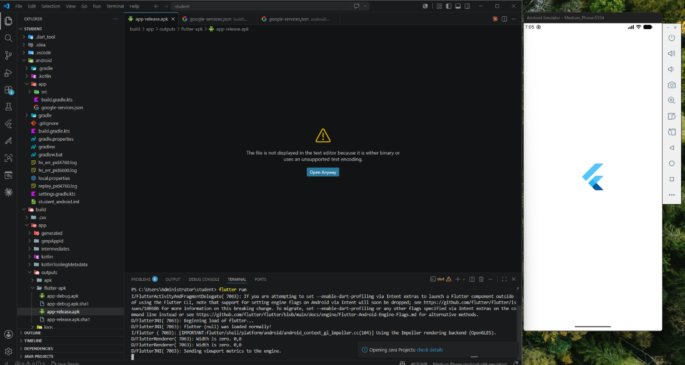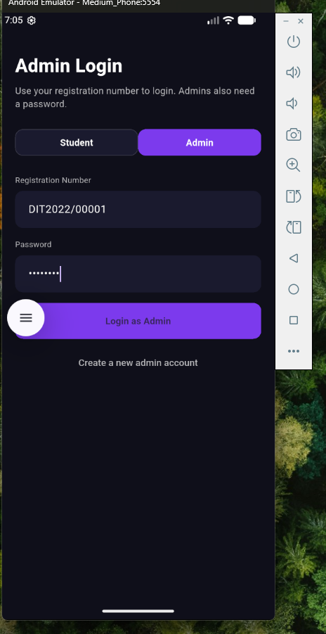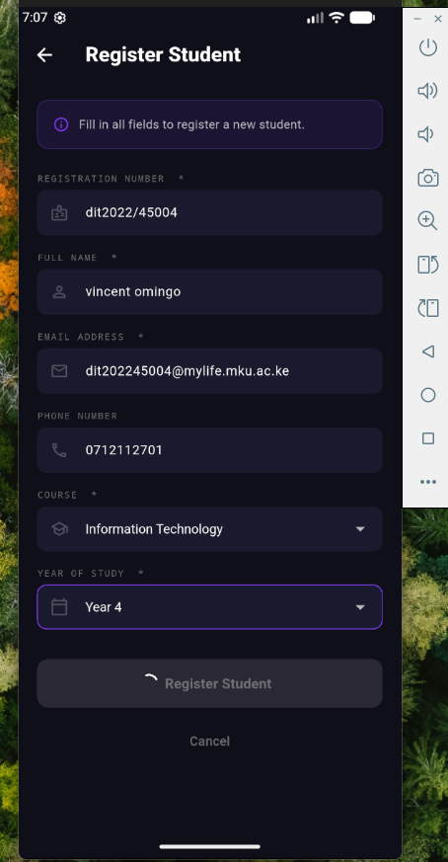
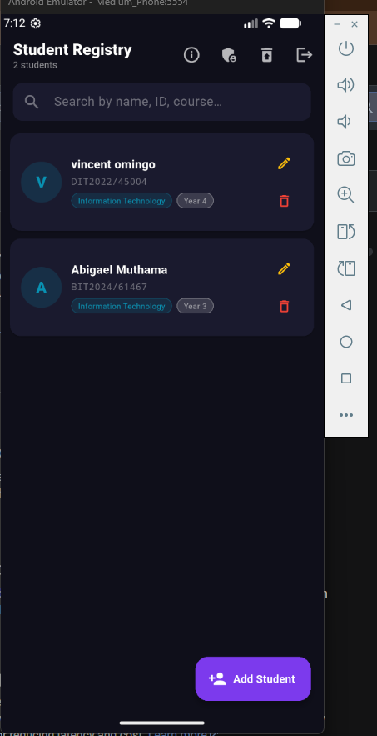

TOOLS/SOFTWARES USED
- Flutter
- Vs code
- Android Studio

PERSONNAL REFLECTION
Working on the Student Record Management App helped me understand the importance of local storage and database management in mobile applications. Implementing CRUD operations strengthened my practical programming skills and problem-solving abilities. I also learned how primary keys ensure data integrity and how SQLite efficiently manages structured data locally.

WEEK 5: NETWORKING
Assignment
Develop a Mobile API Consumer Application that connects to a public REST API and displays records.

PRACTICAL ACTIVITIES UNDERTAKEN

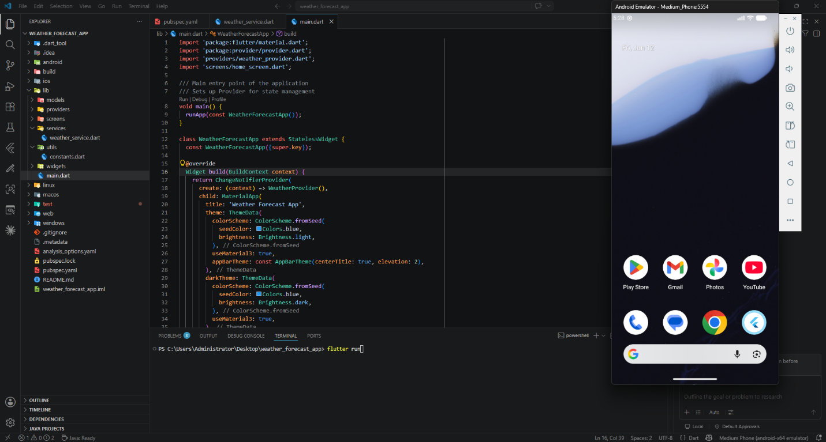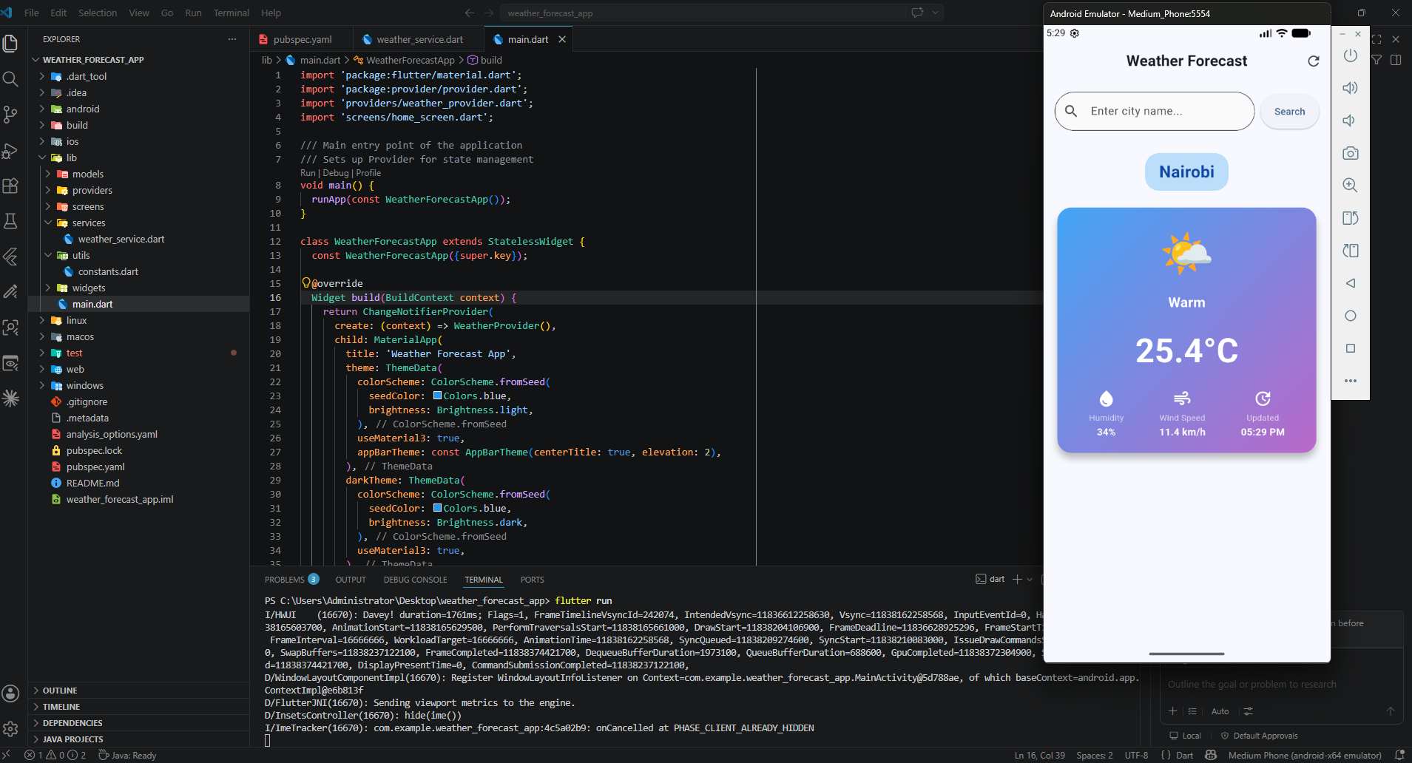
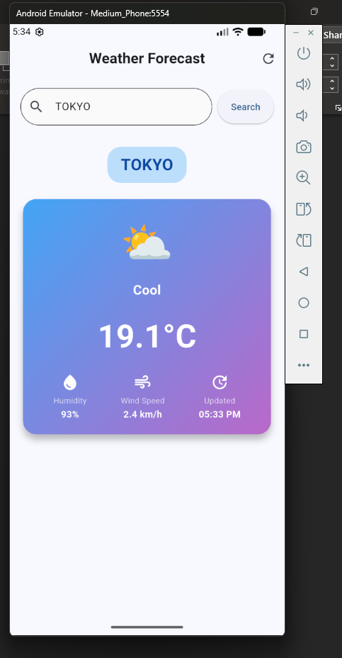

TOOLS/SOFTWARE USED
  - Flutter
  - VS code
  - Android studio

PERSONNAL REFLECTION
Developing the Weather Forecast App enhanced my understanding of networking concepts and REST APIs in Flutter. I learned how to make asynchronous HTTP requests, parse JSON data, and handle errors effectively. The project strengthened my practical skills in API integration, user interface design, and displaying real-time data from web services.

REPORT
Network is essential for data sharing, remote access, updates, and synchronization of student records across systems.

